we already explored interactive visualizations of simple features (i.e., interactive maps) via **ggplot2**’s geom_sf() and **plotly**’s ggplotly().

Code Chunks – Interactive Visualizations of simple features

As the maintainer of the R package **plotly**, I’m certainly aware that ggplotly() is not perfect. And, even when conversion from **ggplot2** to **plotly** ‘works’ it can leave some things to be desired. For example, it might take a while to render, it might not look exactly the way **ggplot2** does, and/or the default interactive properties (e.g., tooltips) might not work the way you want them to. In almost every case, these are issues that, with a bit of knowledge about **plotly** and the underlying plotly.js library, you can fix. That’s because, as long as ggplotly() returns an object, we can inspect its underlying data structure (which, by the way, is useful for learning plotly.js!) and improve on it by modifying that data.[2](https://blog.cpsievert.me/2018/01/30/learning-improving-ggplotly-geom-sf/#fn2) This post explores several ways to learn from, leverage, and improve ggplotly() conversions of **ggplot2**’s geom_sf() (which is still in development), but some of the same lessons can apply more generally to other **ggplot2** geoms.

**Basic intro to geom_sf()**

One awesome consequence of using **sf** is that, since the data structure contains all the geo-spatial information, both plot() and geom_sf() just workTM.

*# to replicate these examples, you currently need the dev version*

*# devtools::install_github('ropensci/plotly')*

*# devtools::install_github('hrbrmstr/albersusa')*

**library**(plotly)

**library**(sf)

**library**(albersusa)

us_laea <- usa_sf("laea")

p <- ggplot(us_laea) + geom_sf()

ggplotly(p)

[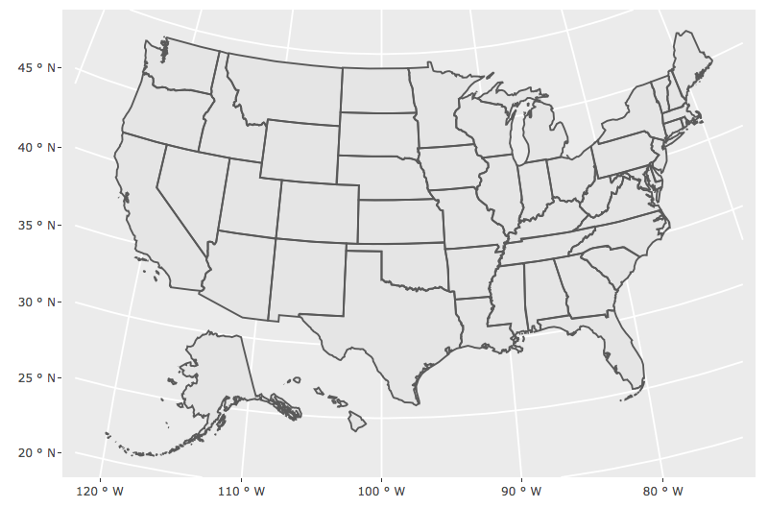](https://blog.cpsievert.me/01-map)

The most brilliant thing about **sf** is that it stores geo-spatial structures in a special list-column of a data frame. This allows each row to represent the real unit of observation/interest – whether be a polygon, multi-polygon, point, line, or even a collection of these features – and as a result, supports workflows that leverage tidy-data principles.

In our case, the us_laea data contains 51 rows (50 states + DC), and the geometry column tracks info about the geo-spatial objects:

**library**(dplyr)

select(us_laea, name, pop_2014, geometry)

Simple feature collection with 51 features and 2 fields

geometry type: MULTIPOLYGON

dimension: XY

bbox: xmin: -2100000 ymin: -2500000 xmax: 2516374 ymax: 732103.3

epsg (SRID): NA

proj4string: +proj=laea +lat_0=45 +lon_0=-100 +x_0=0 +y_0=0 +a=6370997 +b=6370997 +units=m +no_defs

First 10 features:

name pop_2014 geometry

1 Arizona 6731484 MULTIPOLYGON (((-1111066 -8...

2 Arkansas 2966369 MULTIPOLYGON (((557903.1 -1...

3 California 38802500 MULTIPOLYGON (((-1853480 -9...

4 Colorado 5355866 MULTIPOLYGON (((-613452.9 -**...**

5 Connecticut 3596677 MULTIPOLYGON (((2226838 519...

6 District of Columbia 658893 MULTIPOLYGON (((1960720 -41...

7 Georgia 10097343 MULTIPOLYGON (((1379893 -98...

8 Illinois 12880580 MULTIPOLYGON (((868942.5 -2...

9 Indiana 6596855 MULTIPOLYGON (((1279733 -39...

10 Louisiana 4649676 MULTIPOLYGON (((1080885 -16...

Compared to older workflows (e.g., fortify() + geom_polygon()), this is a way more convenient and intuitive data structure (especially if your real unit of interest is the state). Moreover, **sf** tracks additional information about the coordinate system and bounding box which ensures your aspect ratios are always correct and also makes it easy transform and simplify those features (more on this later). It’s worth noting that **sf** is still very new, and improvements are constantly being made – to keep updated, check out the r-spatial blog.

**Tools for improving upon ggplotly() conversions**

Yes, ggplotly() converts the map ‘correctly’, but it does take a while to print, and for some reason, no tooltip appears when hovering over the map. To investigate why, lets examine the JSON that **plotly** sends along to plotly.js to render the map. This can be done via the plotly_json() function, which is useful for seeing how *any* R **plotly** object is serialized as JSON. This JSON represents what we call a *figure*, which is comprised of numerous components – the most important of which are: *layout* (for controlling axes, labels, titles, etc) and *data* (a collection of *traces*, each of which defines a mapping from data to visuals).

*# prints an interactive htmlwidget if you have listviewer*

*# install.packages('listviewer')*

plotly_json(p)

[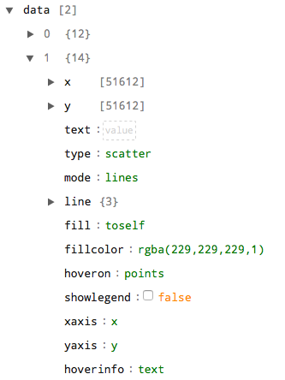](https://blog.cpsievert.me/02-json)

Inspecting the data component, we see that the map contains two 'scatter' traces, both with a mode of 'lines'. The first trace is the graticule behind the states and the second trace contains the state outlines which contain over 50,000+ x/y (i.e., lat/lon) positions! This is certainly not the most efficient way to create such a map and there are several ways we could improve upon it without abandoning the comfort of geom_sf().[5](https://blog.cpsievert.me/2018/01/30/learning-improving-ggplotly-geom-sf/#fn5) Before we dive into those improvements, lets first consider what happens when **plotly** generates a plot.

Whether you’re printing the result of ggplotly(), plot_ly(), or generally any R htmlwidget, there are two main steps that occur: a *build* (i.e. compile) and *render* step. Roughly speaking, the build step translates R code to an R list. That list is then serialized as JSON (via jsonlite::toJSON()) and should match a JSON specification (i.e. schema) defined by the JavaScript library (which uses the JSON to render the widget).

If you’ve ever found ggplotly() slow to print, chances are, the bulk of the time is spent *building* the R list and *sending* the JSON to plotly.js. For many htmlwidgets, the build time is negligible, but for more complex widgets like **plotly**, a lot of things need to happen, especially for ggplotly() since we call ggplot2::ggplot_build(), then crawl and map that data structure to plotly.js. In a shiny app, both the build and render stages are required on initial load, but the new plotlyProxy() interface provides a way to ‘cache’ expensive build (and render!) operation and update a graph by modifying just specific components of the figure (via plotly.js functions). Outside of a ‘reactive context’ like shiny, you could use htmlwidgets::saveWidget() to ‘cache’ the results of the build step to disk, send the file to someone else (or host it online somewhere), then only the render step is required to view the graph.

A quick and easy way to try and improve *render* performance is to use canvas-based rendering (instead of vector-based SVG) with toWebGL(p). Switching from vector to canvas is generally a good idea when dealing with >30,000 vectors, but in this case, we’re only dealing with a couple hundred vector paths, so switching from vector to canvas for our map won’t significantly improve rendering performance, and in fact, we’ll lose some nice SVG exclusive features (the plotly.js team is getting close to eliminating these limitations!). Instead, what we could (and should!) do is reduce the amount of points along to each path (technically speaking, we’ll reduce the complexity of the SVG d attribute).

Thankfully, the **sf** package provides st_simplify() function that may be used to simplify polygons while still preserving their shape. A bit of trial and error is involved, but the idea is that by increasing the value of the dTolerance argument, you’ll decrease the number of points required to draw the spatial features. For fun, before simplifying, lets leverage some more **sf** awesomeness, st_transform(). This function allows us to transform our features to *any* projection via the proj4 standard. Here I’ll transform from laea to lcc, and in this case, a dTolerance of 10000 simplifies from roughly 50,000 to 2,500 points. On my machine, that cuts the build and render time in half and reduces the HTML/JSON file size from 1.7MB to 125.9KB.

**library**(sf)

us_lcc <- usa_sf("laea") %>%

st_transform("+proj=lcc +lat_1=33 +lat_2=45 +lat_0=39 +lon_0=-96 +x_0=0 +y_0=0 +datum=NAD83 +units=m +no_defs") %>%

st_simplify(TRUE, dTolerance = 10000)

plotly_json(ggplot(us_lcc) + geom_sf())

[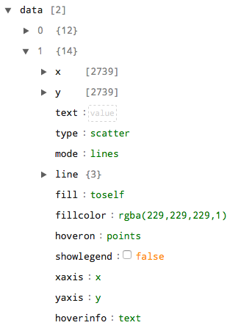](https://blog.cpsievert.me/02-json-b)

Now that we’ve simplified the borders, lets look into why there is no hover information. Since hoverinfo='text', plotly.js just shows the text attribute in the tooltip, but that attribute is blank! It’s blank because, by default, ggplotly() puts all aesthetic mapping information in the text field, but we haven’t actually used an aesthetic mapping here (geom_sf() is weird in that way – it is the only geom that doesn’t require any aesthetics)! We’ll eventually use aesthetic mappings with geom_sf() to create a [choropleth](https://en.wikipedia.org/wiki/Choropleth_map) map, but before we do, lets find out what the other trace attributes are doing (and find other relevant ones).

If you’re ever wondering what a particular attribute means (e.g., text, fill, fillcolor, hoveron, etc), you can look up the description online by going to https://plot.ly/r/reference/#[type]-[attr] for a specific trace [type] and attribute [attr] (e.g. https://plot.ly/r/reference/#scatter-fill). The online reference is nice, but I prefer to use the schema() function for a few reasons:

* schema() provides a bit more information than the online docs (e.g., value types, default values, acceptable ranges, etc).
* The interface makes it a bit easier to traverse and *discover* new attributes.
* You can be absolutely sure it matches the version used in the R package (the online docs might use a different – probably older – version).

schema()

[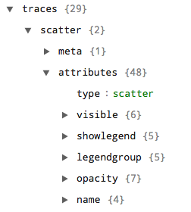](https://blog.cpsievert.me/03-schema)

Go ahead and have a look under “traces” -> “scatter” -> “attributes”. These are all the attributes that may be used to control the appearance and interactive properties of a scatter trace. I won’t bother going through descriptions (you can see those for yourself by expanding an attribute), but I will demonstrate how we can leverage the style() function to modify just the state border’s attributes (specifying traces=2 ensures these changes are only applies to the second trace).

gg <- ggplotly(ggplot(us_lcc) + geom_sf())

style(

gg, traces = 2,

mode = "markers+lines",

hoverinfo = "x+y",

fillcolor = "transparent",

hoverlabel = list(bgcolor = "white")

)

[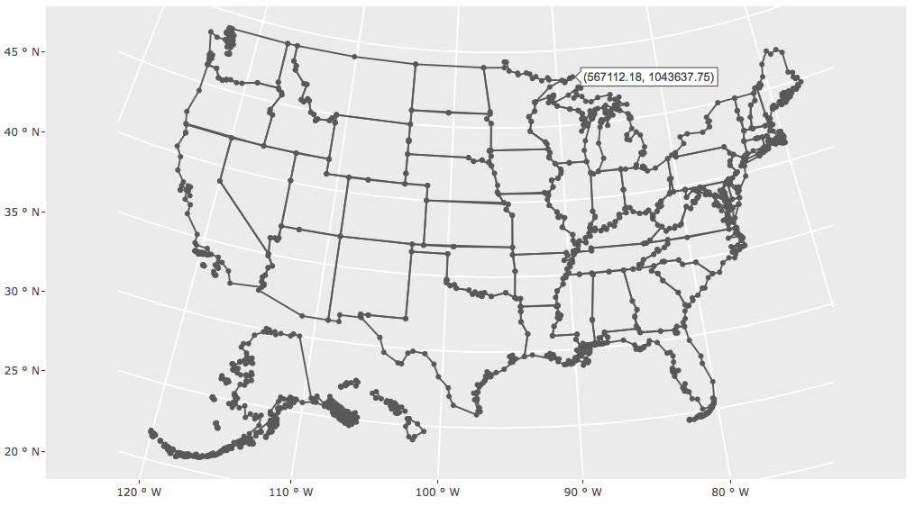](https://blog.cpsievert.me/01-map-modified)

**Leveraging plotly’s interactive features**

After that deep dive into how ggplotly() works under the hood, and tips for improving rendering performance, let’s explore some lesser known, yet powerful ggplotly() features. As a side note, anything that can be done via ggplotly(), you can also do via plot_ly() (but not necessarily the other way round!) – it just might be more effort to do so. And, sometimes this extra effort is worth it, because ggplotly() isn’t really designed to be re-sized without being re-printed .In fact, a lot of times, I prototype plots with ggplotly(), then translate it plot_ly() when it’s time to put it into production.

**Customizing tooltips**

At this point, we’ve learned how to turn a tooltip on/off (via hoverinfo), but perhaps more useful is the ability to completely control what appears in the tooltip. By using ggplotly()’s ability to translate a special text aesthetic with tooltip='text', we can effectively supply any text we want and even style it with HTML tags – as is done in this [choropleth map](https://en.wikipedia.org/wiki/Choropleth_map) encoding population in 2014.

p <- ggplot(us_lcc) +

geom_sf(aes(fill = pop_2014, text = paste("The state of <b>", name, "</b> had \n", pop_2010, "people in 2010")))

p %>%

ggplotly(tooltip = "text") %>%

style(hoverlabel = list(bgcolor = "white"), hoveron = "fill")

[](https://blog.cpsievert.me/01-map-tooltip)

**Animation**

A choropleth map of the population in 2014 is not that interesting, so let’s grab some other data. Here I download physical activity and obesity ‘prevalence’ between 2001-2011 in every US county from the [Global Health Data Exchange](http://ghdx.healthdata.org/). then finding the mean rate for every combination of state and year:

url <- "http://ghdx.healthdata.org/sites/default/files/record-attached-files/IHME_USA_OBESITY_PHYSICAL_ACTIVITY_2001_2011.csv"

**library**(tidyr)

*# reshape and create a column tracking the year*

dat_clean <- readr::read_csv(url) %>%

gather(year, value, matches("prevalence [0-9]+ \\(%\\)")) %>%

mutate(year = stringr::str_extract(year, "[0-9]+"))

*# compute mean outcome for every combination of state/year/outcome*

dat_state <- dat_clean %>%

rename(name = State, outcome = Outcome) %>%

group_by(name, year, outcome) %>%

summarise(value = mean(value, na.rm = TRUE))

*# attach our (simplified) state features to our summaries*

dat_sf <- dat_state %>%

left_join(us_lcc) %>%

st_as_sf() %>%

mutate(txt = paste(name, year, "\n", outcome, scales::percent(value / 100)))

select(dat_sf, name, year, outcome, value, geometry)

Simple feature collection with 1683 features and 4 fields

geometry type: GEOMETRY

dimension: XY

bbox: xmin: -2553435 ymin: -1777696 xmax: 2258071 ymax: 1407299

epsg (SRID): NA

proj4string: +proj=lcc +lat_1=33 +lat_2=45 +lat_0=39 +lon_0=-96 +x_0=0 +y_0=0 +ellps=GRS80 +towgs84=0,0,0,0,0,0,0 +units=m +no_defs

*# A tibble: 1,683 x 5*

*# Groups: name, year [561]*

name year outcome value geometry

<chr> <chr> <chr> <dbl> <sf_geometry [m]>

1 Alabama 2001 Any PA 66.0 MULTIPOLYGON (((761196.5 -9...

2 Alabama 2001 Obesity 34.5 MULTIPOLYGON (((761196.5 -9...

3 Alabama 2001 Sufficient PA 42.7 MULTIPOLYGON (((761196.5 -9...

4 Alabama 2002 Any PA 66.8 MULTIPOLYGON (((761196.5 -9...

5 Alabama 2002 Obesity 35.4 MULTIPOLYGON (((761196.5 -9...

6 Alabama 2002 Sufficient PA NaN MULTIPOLYGON (((761196.5 -9...

7 Alabama 2003 Any PA 67.5 MULTIPOLYGON (((761196.5 -9...

8 Alabama 2003 Obesity 36.2 MULTIPOLYGON (((761196.5 -9...

9 Alabama 2003 Sufficient PA 44.6 MULTIPOLYGON (((761196.5 -9...

10 Alabama 2004 Any PA 67.7 MULTIPOLYGON (((761196.5 -9...

*# ... with 1,673 more rows*

There’s a number of ways we could try to visualize how physical activity and/or obesity has evolved over the years. One way would be to create a small multiple display (one for every year via facet_wrap(~ year)), but it’s a bit less visual work to perceive differences via animation. Creating animations with ggplotly() is very similar to gganimate – we just add an aesthetic mapping of frame = year.

obesity <- filter(dat_sf, outcome == "Obesity")

p <- ggplot(obesity) +

geom_sf(aes(fill = value, frame = year, text = txt)) +

ggtitle("Obesity rates in the US over time") +

ggthemes::theme_map()

plotly_json(p)

[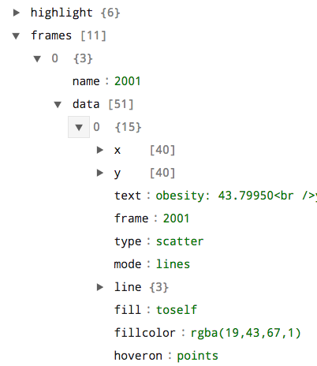](https://blog.cpsievert.me/04-frame-json)

Having a look at the underlying JSON reveals a special *frame* component which adheres to the underlying plotly.js animation api. It turns out that the data supplied to each frame of the animation has a bunch of redundant information. Specifically, the x/y coordinates for the state boundaries are repeated on every frame – which we don’t really need to do in this case, so let’s remove that data before printing:

*# ggplotly() won't (for good reason) "register" an animation*

*# until print time, so to acess/modify the frames component,*

*# you'll need plotly_build() -- use this function when you*

*# want to be *absolutely* sure you're accessing the full list/JSON*

gg <- p %>%

ggplotly(tooltip = "text") %>%

style(hoveron = "fill") %>%

plotly_build()

*# remove x/y data from every trace*

gg$x$frames <- lapply(

gg$x$frames, **function**(f) {

f$data <- lapply(f$data, **function**(d) d[!names(d) %**in**% c("x", "y")])

f

})

gg

[](https://blog.cpsievert.me/04-animation)

**Highlighting**

In addition to animation, plotly has powerful framework for filtering, highlighting, and linking views without shiny. This framework leverages the SharedData class from **crosstalk** package where one essentially defines a “unit of interaction” using a column from the data to be visualized. In our case, we can set name (i.e, state) as the interaction unit, then when we trigger a selection (e.g., brush a time series of physical actively), the relevant graphical marks are highlighted in every view:

[](https://blog.cpsievert.me/05-obesity-linked)

**library**(crosstalk)

dat_shared <- dat_sf %>%

filter(!is.na(value)) %>%

SharedData$new(~name, "A")

p <- ggplot(dat_shared) +

geom_line(aes(x = year, y = value, group = name)) +

facet_wrap(~outcome, scales = "free") +

theme_bw()

lines <- p %>%

ggplotly(tooltip = "name") %>%

style(mode = "markers+lines") %>%

layout(dragmode = "select") %>%

highlight("plotly_selected")

*# compute mean obesity for each state, define "state" as interaction unit (in group "A")*

ob_mean <- obesity %>%

group_by(name) %>%

summarise(mean_obesity = mean(value)) %>%

mutate(txt = paste(name, "mean \n obesity", scales::percent(mean_obesity / 100))) %>%

SharedData$new(~name, "A")

map <- ggplot(ob_mean) +

geom_sf(aes(fill = mean_obesity, text = txt)) +

ggthemes::theme_map()

**library**(htmltools)

browsable(tagList(ggplotly(map, tooltip = "text"), lines))

**Discussion**

Compared to other interactive mapping approaches, using geom_sf() + ggplotly() has it’s pros and its cons. It terms of it’s ability to link multiple views, it seems to be the most advanced, but there are a number of other features you might want (e.g., dynamic zooming of different baselayers). I think a good number of these can be resolved by using **sf** with [plot_mapbox()](https://plot.ly/r/scattermapbox/) and better support for that should be coming soon, but it would also be nice to see **leaflet**

As it turns out, **plotly**’s ‘highlighting’ framework can actually be used to do much more than just highlighting. It works by adding additional traces that reflect the selected data and the attributes of these trace(s) can be customized. When used in clever ways, that capability can be used : [](https://gist.github.com/cpsievert/fa56bd89122e395803f30602b774dbe1)

This time we’ll make similar visualizations using **plotly**’s “non-ggplot2” mapping interfaces (namely plot_ly(), plot_geo(), and plot_mapbox()). Here’s a quick example of reading a shape file into R as simple features via st_read(), then plotting those features (in this case, North Carolina counties) using each one of the four mapping approaches **plotly** provides. Notice how all of these options auto-magically know how to render simple features:

library(plotly)

nc <- sf::st_read(system.file("shape/nc.shp", package = "sf"), quiet = TRUE)

class(nc)

#> [1] "sf" "data.frame"

subplot(nrows = 2,

ggplot(nc) + geom_sf(),

plot_ly(nc),

plot_geo(nc),

plot_mapbox(nc)

) %>% hide_legend()

[[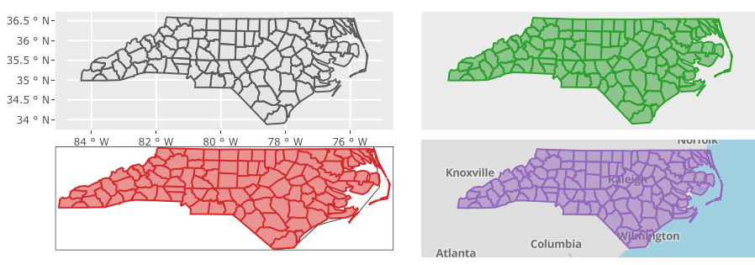](https://blog.cpsievert.me/06-sf-options.html)](https://blog.cpsievert.me/06-sf-options.html)

You might be wondering, “What can **plotly** offer over other interactive mapping packages such as **leaflet**, **mapview**, **mapedit**, etc?”. One big feature is the linked brushing framework, which works best when linking **plotly** together with other **plotly** graphs (i.e., only a subset of brushing features are supported when linking to other crosstalk-compatible htmlwidgets). Another is the ability to leverage the plotly.js API to make efficient updates in shiny apps [via plotlyProxy()](https://blog.cpsievert.me/2017/07/13/plotly-4.7.1-now-on-cran/). Speaking of efficiency, plotly.js keeps on improving the performance of their WebGL-based rendering, so I recommend trying plot_ly() (with toWebGL()) and/or plot_mapbox() if you have lots of graphical elements to render. Also, by having a consistent interface between these various mapping approaches, it’s much quicker and easier to switch from one approach to another when you need to leverage a different set.

Speaking of strengths, plotly.js also has -class 3D rendering support. When used in combination with **plotly**’s linking framework, we can do some nifty things – all inside self-contained HTML

# To see the actual R code that generates the self-contained HTML result,

# enter this in your R console or visit

demo("sf-plotly-3D-globe", package = "plotly")

I’ve also added new stroke and span arguments which make it easier to control the outline color and width of filled polygons/markers/bars/etc. These new arguments work in a similar way to existing arguments like color and linetype. In particular, constant values can be specified via I():

plot_ly(nc, stroke = I("#119dff"), span = I(5), color = I("#00cc96"), linetype = I("dash"))

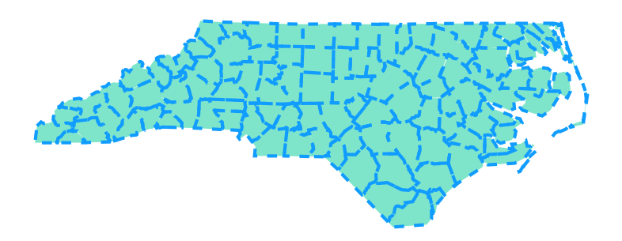

Furthermore, values not wrapped in I() are mapped to a visual range defined by the plural form of the argument (i.e., strokes and spans). However, to effectively map data to these sorts of visuals, we might want to generate mutliple traces.

**One trace to rule them all?**

One of the trickiest things about mastering **plotly** and/or plotly.js is knowing what can and can not be done with just one trace. That’s why, by default, the maps above are implemented with just one trace. However, when you need certain scalar (i.e., non-data-array) trace properties (e.g. fillcolor) to vary, you might want to use split to create a trace for every level in the split variable. For example, in this map of [territories](https://en.wikipedia.org/wiki/First-level_NUTS_of_the_European_Union) in [Franconia](https://en.wikipedia.org/wiki/Franconia), we ensure one trace per territory (via the split argument), which leads to two fairly obvious features:

1. The ability to hide/show territories by clicking (or double-clicking) legend entries. As we’ll discuss later, there are actually ways to do this sort of thing with *just one trace* via the crosstalk (i.e. linked views) framework.
2. A different color for each territory. In this case, we’ve used split without specifying color, so plotly.js will impose it’s default coloring rules, but you could easily set a constant color across traces (e.g., color = I("black")) or, as we’ll see shortly, use a custom color scheme.

# load trails data (an sf object bundled with the mapview package)

# install.packages('mapview')

data(franconia, package = "mapview")

# Compare this result with: `plot_ly(franconia, split = ~NAME_ASCI, color = I("black"))`

plot_ly(franconia, split = ~NAME_ASCI)

[[](https://blog.cpsievert.me/franconia-split.html)](https://blog.cpsievert.me/franconia-split.html)

Having a different trace for each territory opens the door for further territory-level customization, such as having a custom color, linetype, fill-specific tooltip, etc. When color is *numeric*, and you want it to set a different fill-color for certain polygon(s), you’ll need split to ensure there is no more than one color per trace:

plot_ly(

franconia,

split = ~NUTS_ID,

color = ~SHAPE_AREA,

alpha = 1,

showlegend = FALSE

)

[[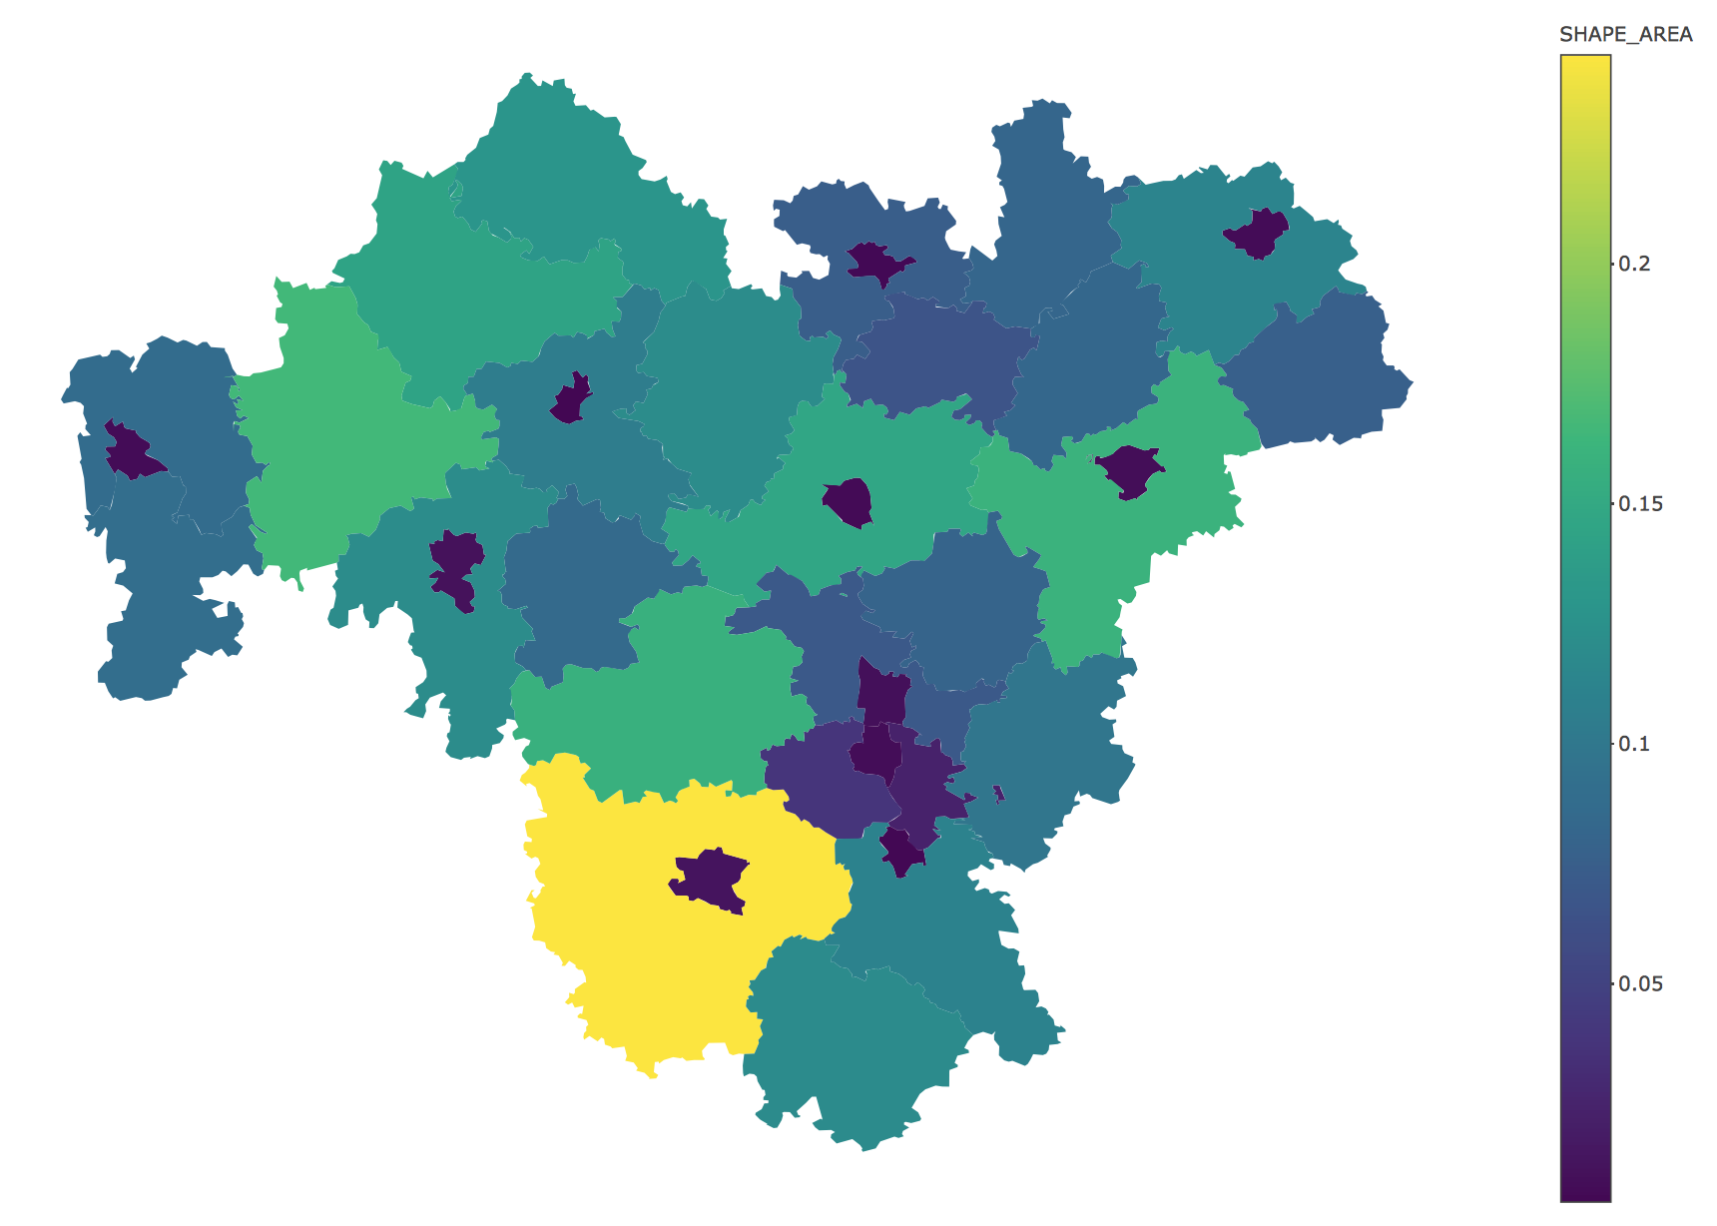](https://blog.cpsievert.me/franconia-choro.html)](https://blog.cpsievert.me/franconia-choro.html)

On the other hand, if color is a discrete variable, plot_ly() always produces one trace per level. Since, in this case, there are over 30 districts, I’m going to use a color palette that does a fairly good job in distinguishing between a large number of groups:

cols <- c("#89C5DA", "#DA5724", "#74D944", "#CE50CA", "#3F4921", "#C0717C", "#CBD588", "#5F7FC7", "#673770", "#D3D93E", "#38333E", "#508578", "#D7C1B1", "#689030", "#AD6F3B", "#CD9BCD", "#D14285", "#6DDE88", "#652926", "#7FDCC0", "#C84248", "#8569D5", "#5E738F", "#D1A33D", "#8A7C64", "#599861")

plot_ly(franconia, color = ~NAME_ASCI, colors = cols, alpha = 1)

[[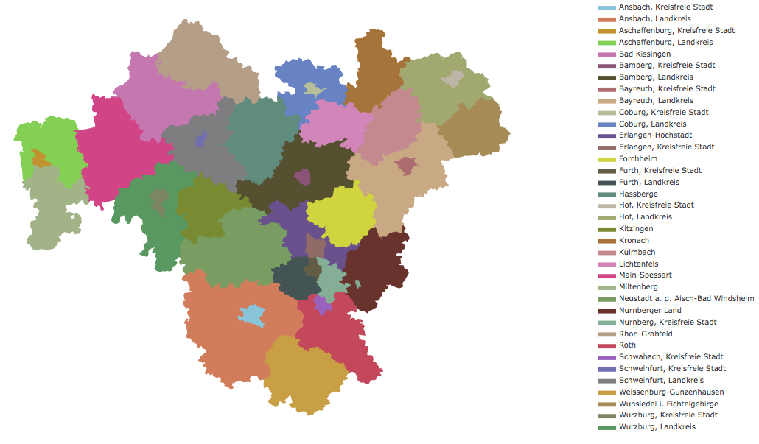](https://blog.cpsievert.me/franconia-color-discrete.html)](https://blog.cpsievert.me/franconia-color-discrete.html)

Note that you can still color multiple traces the same color, but if you want to have a different tooltip to appear upon hovering a specific set of polygons (as opposed to along each point), you’ll want to still use split in combination with hoveron = "fill":

plot_ly(

franconia,

split = ~NUTS_ID,

color = ~district,

stroke = I("black"),

text = ~paste(NAME_ASCI, "\n is in", district),

hoverinfo = "text",

hoveron = "fill"

)

[[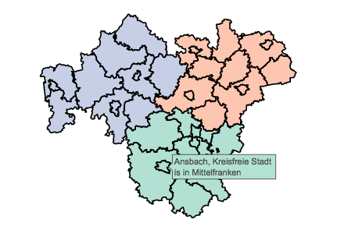](https://blog.cpsievert.me/franconia-color-split.html)](https://blog.cpsievert.me/franconia-color-split.html)

**Leveraging mapbox basemaps**

Among the four mapping options, the one that excites me the most is plot_mapbox(). The primary reason to use plot_mapbox() (or plot_geo()) over geom_sf() (or plot_ly()) is that these approaches include a base-map layer which updates dynamically on zoom and can quite helpful for providing geographic context. The base-map styling can be easily customized – especially for plot_mapbox() via the layout.mapbox.style attribute. In addition to a URL to a custom style, you can provide this attribute with a pre-packaged style name. To get a list of those pre-packaged styles, reach into the plotly.js plot schema():

styles <- schema()$layout$layoutAttributes$mapbox$style$values

styles

[1] "basic" "streets" "outdoors" "light"

[5] "dark" "satellite" "satellite-streets"

A nice feature to include with these maps is a dropdown to dynamically change the base-map styling. To do so, use the layout.updatemenus.buttons attribute to control the value of the layout.mapbox.style attribute. Since we wish to modify the layout.mapbox.style attribute, which is part of the plot’s layout, we’ll want each dropdown “button” to trigger a relayout event with the appropriate args. Here is one way to create a list of buttons, one for each of the default styles:

# generate plot.js buttons, one for every style

style_buttons <- lapply(styles, function(s) {

list(label = s, method = "relayout", args = list("mapbox.style", s))

})

With our list of style_buttons, we’re now ready to visualize something. Here I’ll leverage the trails data from the **mapview** package, which has a number of hiking trails of Franconia, Germany.

data(trails, package = 'mapview')

plot_mapbox(trails, color = I("black")) %>%

layout(

title = "Selected hiking trails in Franconia",

mapbox = list(style = "satellite-streets"),

updatemenus = list(list(y = 0.8, buttons = rev(style_buttons)))

)

[[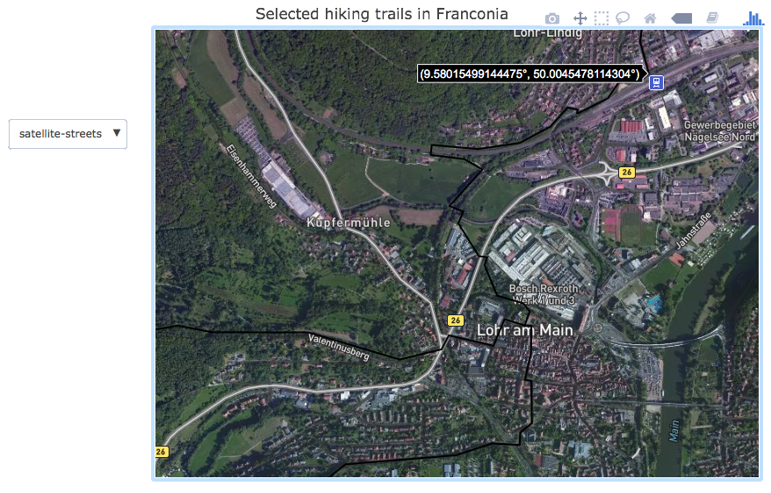](https://blog.cpsievert.me/07-satellite.html)](https://blog.cpsievert.me/07-satellite.html)

As a side note, you could also use **shiny** to modify the basemap layer without redrawing the entire plot, but the result here is self-contained HTML/SVG, which is **much easier** to share, host, scale, and maintain.

Code Chunks – Plotly 4.7.1 is now on CRAN

I'm excited to announce that plotly 4.7.1 is now on CRAN! Along with some important bug fixes and numerous improvements to the underlying plotly.js library, this release includes an exciting new R-specific feature -- the ability to modify (i.e., update without a full redraw) an existing plotly graph inside a shiny app via the new plotlyProxy() function. In other words, this proxy interface allows one to perform more efficient and responsive updates to a plotly graph within a shiny app. Before I provide an overview of the proxy interface, lets jump right into some of new plotly.js goodies.

## New plotly.js goodies

Upgrading the R package from 4.7.0 to 4.7.1 upgrades the corresponding plotly.js version from 1.27.1 to 1.29.2. A number of exciting improvements have been added, just to name a few: select/lasso events for scattergl/scattermapbox trace types, 3D annotations, contour labelling, and even touch events on mobile. For quite a while now, R users have been able to link multiple views (without shiny) using nearly any (SVG) trace type (e.g., scatter, bar, heatmap, etc), but the new brush events on scattergl/scattermapbox trace types allow us to brush way more points and trigger selections via a map. Here is an example of highlighting earthquakes west of Fiji to compare the relative frequency of their magnitude and number of reporting stations (to the overall relative frequency):



And the R code to generate the (self-contained!) HTML:

**library**(crosstalk)

eqs <- SharedData$new(quakes)

*# you need a mapbox API key to use plot_mapbox()*

*# https://www.mapbox.com/signup/?route-to=https://www.mapbox.com/studio/account/tokens/*

map <- plot_mapbox(eqs, x = ~long, y = ~lat) %>%

add_markers(color = ~depth) %>%

layout(

mapbox = list(

zoom = 2,

center = list(lon = ~mean(long), lat = ~mean(lat))

)

) %>%

highlight("plotly_selected")

*# shared properties of the two histograms*

hist_base <- plot_ly(eqs, color = I("black"), histnorm = "probability density") %>%

layout(barmode = "overlay", showlegend = FALSE) %>%

highlight(selected = attrs_selected(opacity = 0.5))

histograms <- subplot(

add_histogram(hist_base, x = ~mag),

add_histogram(hist_base, x = ~stations),

nrows = 2, titleX = TRUE

)

bscols(histograms, map)

Another super cool and easy-to-use plotly.js feature is contour line labelling:

plot_ly(z = volcano, type = "contour", contours = list(showlabels = TRUE)) %>%

colorbar(title = "Elevation \n in meters")

## Modifying plotly graphs via plotlyProxy()

The design of **plotly**'s new proxy interface is inspired by similar interfaces in **leaflet** and **DT** (thanks Joe Cheng and Yihui Xie!). That is, plotlyProxy() initiates a proxy object just like leafletProxy()/dataTableProxy() by referencing a shiny output ID. However, at least for now, you must use the plotlyProxyInvoke() function to modify a plotlyProxy() object, which requires knowledge/use of a plotly.js method for the updating logic (among them, Plotly.restyle, Plotly.relayout, Plotly.addTraces, and Plotly.deleteTraces are the most widely useful). This simple shiny app uses Plotly.restyle to change the fillcolor of Canada (i.e., polygons) in response to the dropdown.



Notice how the map and the outline of Canada are not effected (i.e., are not redrawn) when the fill color changes. The code for the app is below. Notice how, instead of having renderPlotly() regenerate the map in response to a change in input$color (i.e., the "old" or "naive" way of updating a plotly graph which always uses Plotly.newPlot), it uses Plotly.restyle via plotlyProxyInvoke() to perform a more efficient update.

*# you can also run this example via the new plotly_example() function!*

*# plotly_example("shiny", "proxy_restyle_canada")*

**library**(shiny)

**library**(plotly)

ui <- fluidPage(

selectInput("color", "Canada's fillcolor", colors(), selected = "black"),

plotlyOutput("map")

)

server <- **function**(input, output, session) {

output$map <- renderPlotly({

map_data("world", "canada") %>%

group_by(group) %>%

plot_mapbox(x = ~long, y = ~lat, color = I("black")) %>%

add_polygons() %>%

layout(

mapbox = list(center = list(lat = ~median(lat), lon = ~median(long)))

)

})

observeEvent(input$color, {

plotlyProxy("map", session) %>%

plotlyProxyInvoke("restyle", list(fillcolor = toRGB(input$color)))

})

}

shinyApp(ui, server)

It's worth noting that using plotlyProxyInvoke() requires knowledge of the figure reference and the plotly.js API. Thus, it can help to have some knowledge of how your plots are actually represented in JSON, which you can always obtain via plotly_json(), for example:

p <- plot_ly(economics, x = ~pce, y = ~psavert, z = ~unemploy, color = ~as.numeric(date), mode = "markers+lines")

plotly_json(p)



This gives us a glimpse into what the R package actually sends along to the newPlot method to generate the initial view on page load. In this case, the R package generates scatter3d marker and line objects. We could use a similar plotlyProxyInvoke() pattern as before to alter the value of certain attribute(s) of these objects (e.g., marker/line size/width):



*# you can also run this example via the new plotly_example() function!*

*# plotly_example("shiny", "proxy_restyle_economics")*

**library**(shiny)

**library**(plotly)

ui <- fluidPage(

sliderInput("marker", "Marker size", min = 0, max = 20, value = 8),

sliderInput("path", "Path size", min = 0, max = 30, value = 2),

plotlyOutput("p")

)

server <- **function**(input, output, session) {

output$p <- renderPlotly({

plot_ly(

economics, x = ~pce, y = ~psavert, z = ~unemploy,

color = ~as.numeric(date), mode = "markers+lines"

)

})

observeEvent(input$marker, {

plotlyProxy("p", session) %>%

plotlyProxyInvoke(

"restyle",

*# could also do list(marker = list(size = input$marker))*

*# but that overwrites the existing marker definition*

*# https://github.com/plotly/plotly.js/issues/1866#issuecomment-314115744*

list(marker.size = input$marker)

)

})

observeEvent(input$path, {

plotlyProxy("p", session) %>%

plotlyProxyInvoke(

"restyle", list(line.width = input$path)

)

})

}

shinyApp(ui, server)

At this point, you might be wondering something along these lines of: "how on earth am I supposed to know/remember what attributes a scatter3d line object has?" One option is to search through the figure reference, but I prefer to use the schema() function since it allows me to more easily traverse the reference and get more information about acceptable/default attribute values. For example, when creating this app, I forgot what line attribute controlled its size/width, so I did the following:

**Linking views without shiny**

In terms of linked brushing *in self-contained HTML*, **plotly** is definitely the most advanced **crosstalk**-compatible htmlwidget. You’ll be able to do more when linking **plotly** to **plotly**, but since persistent selection was recently added to **DT**, let’s demonstrate linking **plotly** with **DT**. To link views via **crosstalk**, you’ll want to supply a data frame of interest to the SharedData$new() method and route the resulting object to any plots that you want to link. By default, the row index (which, in this case, is a simple feature) is used to define the graphical queries, but you can also reference a (discrete) variable to achieve generalized selections (e.g., you could query all trails in a district via SharedData$new(trails, ~district)). Linking **plotly** with **DT** in this way gives us a pretty powerful way to identify simple features both directly and indirectly.

library(crosstalk)

tsd <- SharedData$new(trails)

bscols(

plot_mapbox(tsd, text = ~FKN, hoverinfo = "text"),

DT::datatable(tsd)

)

[[](https://blog.cpsievert.me/08-trails-dt.html)](https://blog.cpsievert.me/08-trails-dt.html)

To provide a sneak peak into the power of the linking framework in **plotly**, let’s leverage a fairly recent feature: brushing of aggregated traces. This example demonstrates how to brush a histogram, but a similar approach could be used to brush other aggregated traces (e.g., add_histogram2d(), add_boxplot(), etc). In fact, one could replicate this example with add_bars() (instead of add_histogram()) by pre-computing bars heights and using a list-column key to assign multiple counties to each bar. In either case (add_bars() or add_histogram()), it is usually a good idea to set layout.barmode = "overlay" so that newly added bars don’t use the plotly.js default of dodging the existing bars. In the case where we let plotly.js dynamically compute aggregates (i.e., add_histogram()) it’s also a good idea to also define xbins (or ybins) so that binning of new bars use the same rules as the existing (i.e. initial) bars.

ncsd <- SharedData$new(nc)

bscols(

plot_mapbox(ncsd) %>%

highlight(dynamic = TRUE, persistent = TRUE),

plot_ly(ncsd, x = ~AREA) %>%

add_histogram(xbins = list(start = 0, end = 0.3, size = 0.02)) %>%

layout(barmode = "overlay") %>%

highlight("plotly_selected", persistent = TRUE)

)

[[](https://blog.cpsievert.me/crosstalk-aggregates.html)](https://blog.cpsievert.me/crosstalk-aggregates.html)

**More learning resources**

At least currently, the best examples of using **sf** with **plotly** are within the package demos. Any demo names that are prefixed with ‘sf’ when you look at the list provided by demo(package = "plotly") are relevant. For example, demo("sf-dt", package = "plotly") gives an example of querying simple feature data by linking plot_mapbox() with **DT** via **crosstalk**..

**Appendix: strengths and weaknesses**

Below is a list of strengths (blue) and weaknesses (red) for each mapping approach in **plotly**. Note that plotly.js is still under development, so this list is likely change a bit:

**1. plot_ly() and geom_sf()**

* Render in SVG or WebGL (toWebGL() makes SVG -> WebGL easy) 
  + fill='toself' is still buggy in WebGL 
* Make 3D visuals by adding a z attribute 
  + With a bit of math, you can project any lat/lon data onto a sphere (i.e. globe) and color the globe’s surface according to some measure, [like radiation](https://github.com/cpsievert/Weather_Stuff/blob/ba80004/radiation-plot-3D.R#L33-L41) 
  + Unlike 2D lines, 3D lines support a color gradient 
  + Using subplot() with 3D doesn’t currently rescale domains correctly 
* Works with any coordinate system 
  + Currently no way to update a graticule on zoom 

**2. plot_mapbox()**

* Full customization of base-maps that provide geo-graphic context 
* WebGL infrastructure allows one to render lots of graphical elements 

**3. plot_geo():**

* Somewhat customization base-maps provide geo-graphic context 
  + Compared to plot_mapbox(), base-map styling is quite limited 
* Supports [orthographic](https://en.wikipedia.org/wiki/Orthographic_projection) (3D) projections as well as a number of other 2D projections 